Comparison of different methods for analysis of simple undamped pendulum with Calcpad
Input parameters  Gravitational acceleration (m/s²) - $g=9.81\frac{\text{ m}}{{\text{ s}}^{2}}$  Pendulum length - $l=1\text{ m}$  Pendulum mass - $m=1\text{ kg}$  Initial angle - $θ_{0}=\text{-}60\text{ °}=\text{-}1.05\text{ rad}$  Maximum simulation time - $t_{max}=10\text{ s}$  Analytical solution for small rotations  $θ$ ≪ 1 or sin($θ$) ≈ $θ$ | 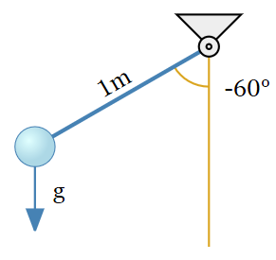
Differential equation - $θ″+\frac{g}{l}·θ=0$
Angular frequency - $ω=\sqrt{\frac{g}{l}}·\text{ rad}=3.13\text{ rad}/\text{ s}$
Cyclic frequency - $f=\frac{ω}{2·π·\text{ rad}}=0.498\text{ Hz}$
Period - $T=\frac{1}{f}=2.01\text{ s}$
Equation of motion - $θ\left(t\right)=θ_{0}·\text{cos}\left(ω·t\right)$
Analytical solution for large rotations (exact)
Differential equation - $θ″+\frac{g}{l}·\text{sin}\left(θ\right)=0$
Incomplete elliptic integral of the first kind
$$F\left(φ;k\right)=\int_{0}^{φ}{\frac{1}{\sqrt{1-k^{2}·{\text{sin}\left(θ\right)}^{2}}} dθ}$$
Jacobi elliptic functions
Modulus - $k=\text{sin}\left(\frac{θ_{0}}{2}\right)=\text{-}0.5$
$$am\left(u;k\right)=\$Root\left\{F\left(φ;k\right)=u;φ∈\left[0;10·π\right]\right\}$$
$sn\left(u;k\right)=\text{sin}\left(am\left(u;k\right)\right)$ , $cn\left(u;k\right)=\text{cos}\left(am\left(u;k\right)\right)$
$dn\left(u;k\right)=\sqrt{1-k·{sn\left(u;k\right)}^{2}}$ , $cd\left(u;k\right)=\frac{cn\left(u;k\right)}{dn\left(u;k\right)}$
Period - $T_{e}=4·\sqrt{\frac{l}{g}}·F\left(\frac{π}{2};k\right)=2.15\text{ s}$
Error - $δ_{T}=\frac{\left|T-T_{e}\right|}{T_{e}}=6.82\text{ \%}$
Cyclic frequency - $f_{e}=\frac{1}{T_{e}}=0.464\text{ Hz}$
Angular frequency - $ω_{e}=2·π·\text{ rad}·f_{e}=2.92\text{ rad}/\text{ s}$
Equation of motion - $θ_{e}\left(t\right)=2·\text{asin}\left(k·cd\left(\sqrt{\frac{g}{l}}·t;k\right)\right)$
Energy - $E_{0}=m·l·g·\left(1-\text{cos}\left(θ_{0}\right)\right)=4.9\text{ J}$
Relative error [%] of small displacements period versus initial angle [°] plot
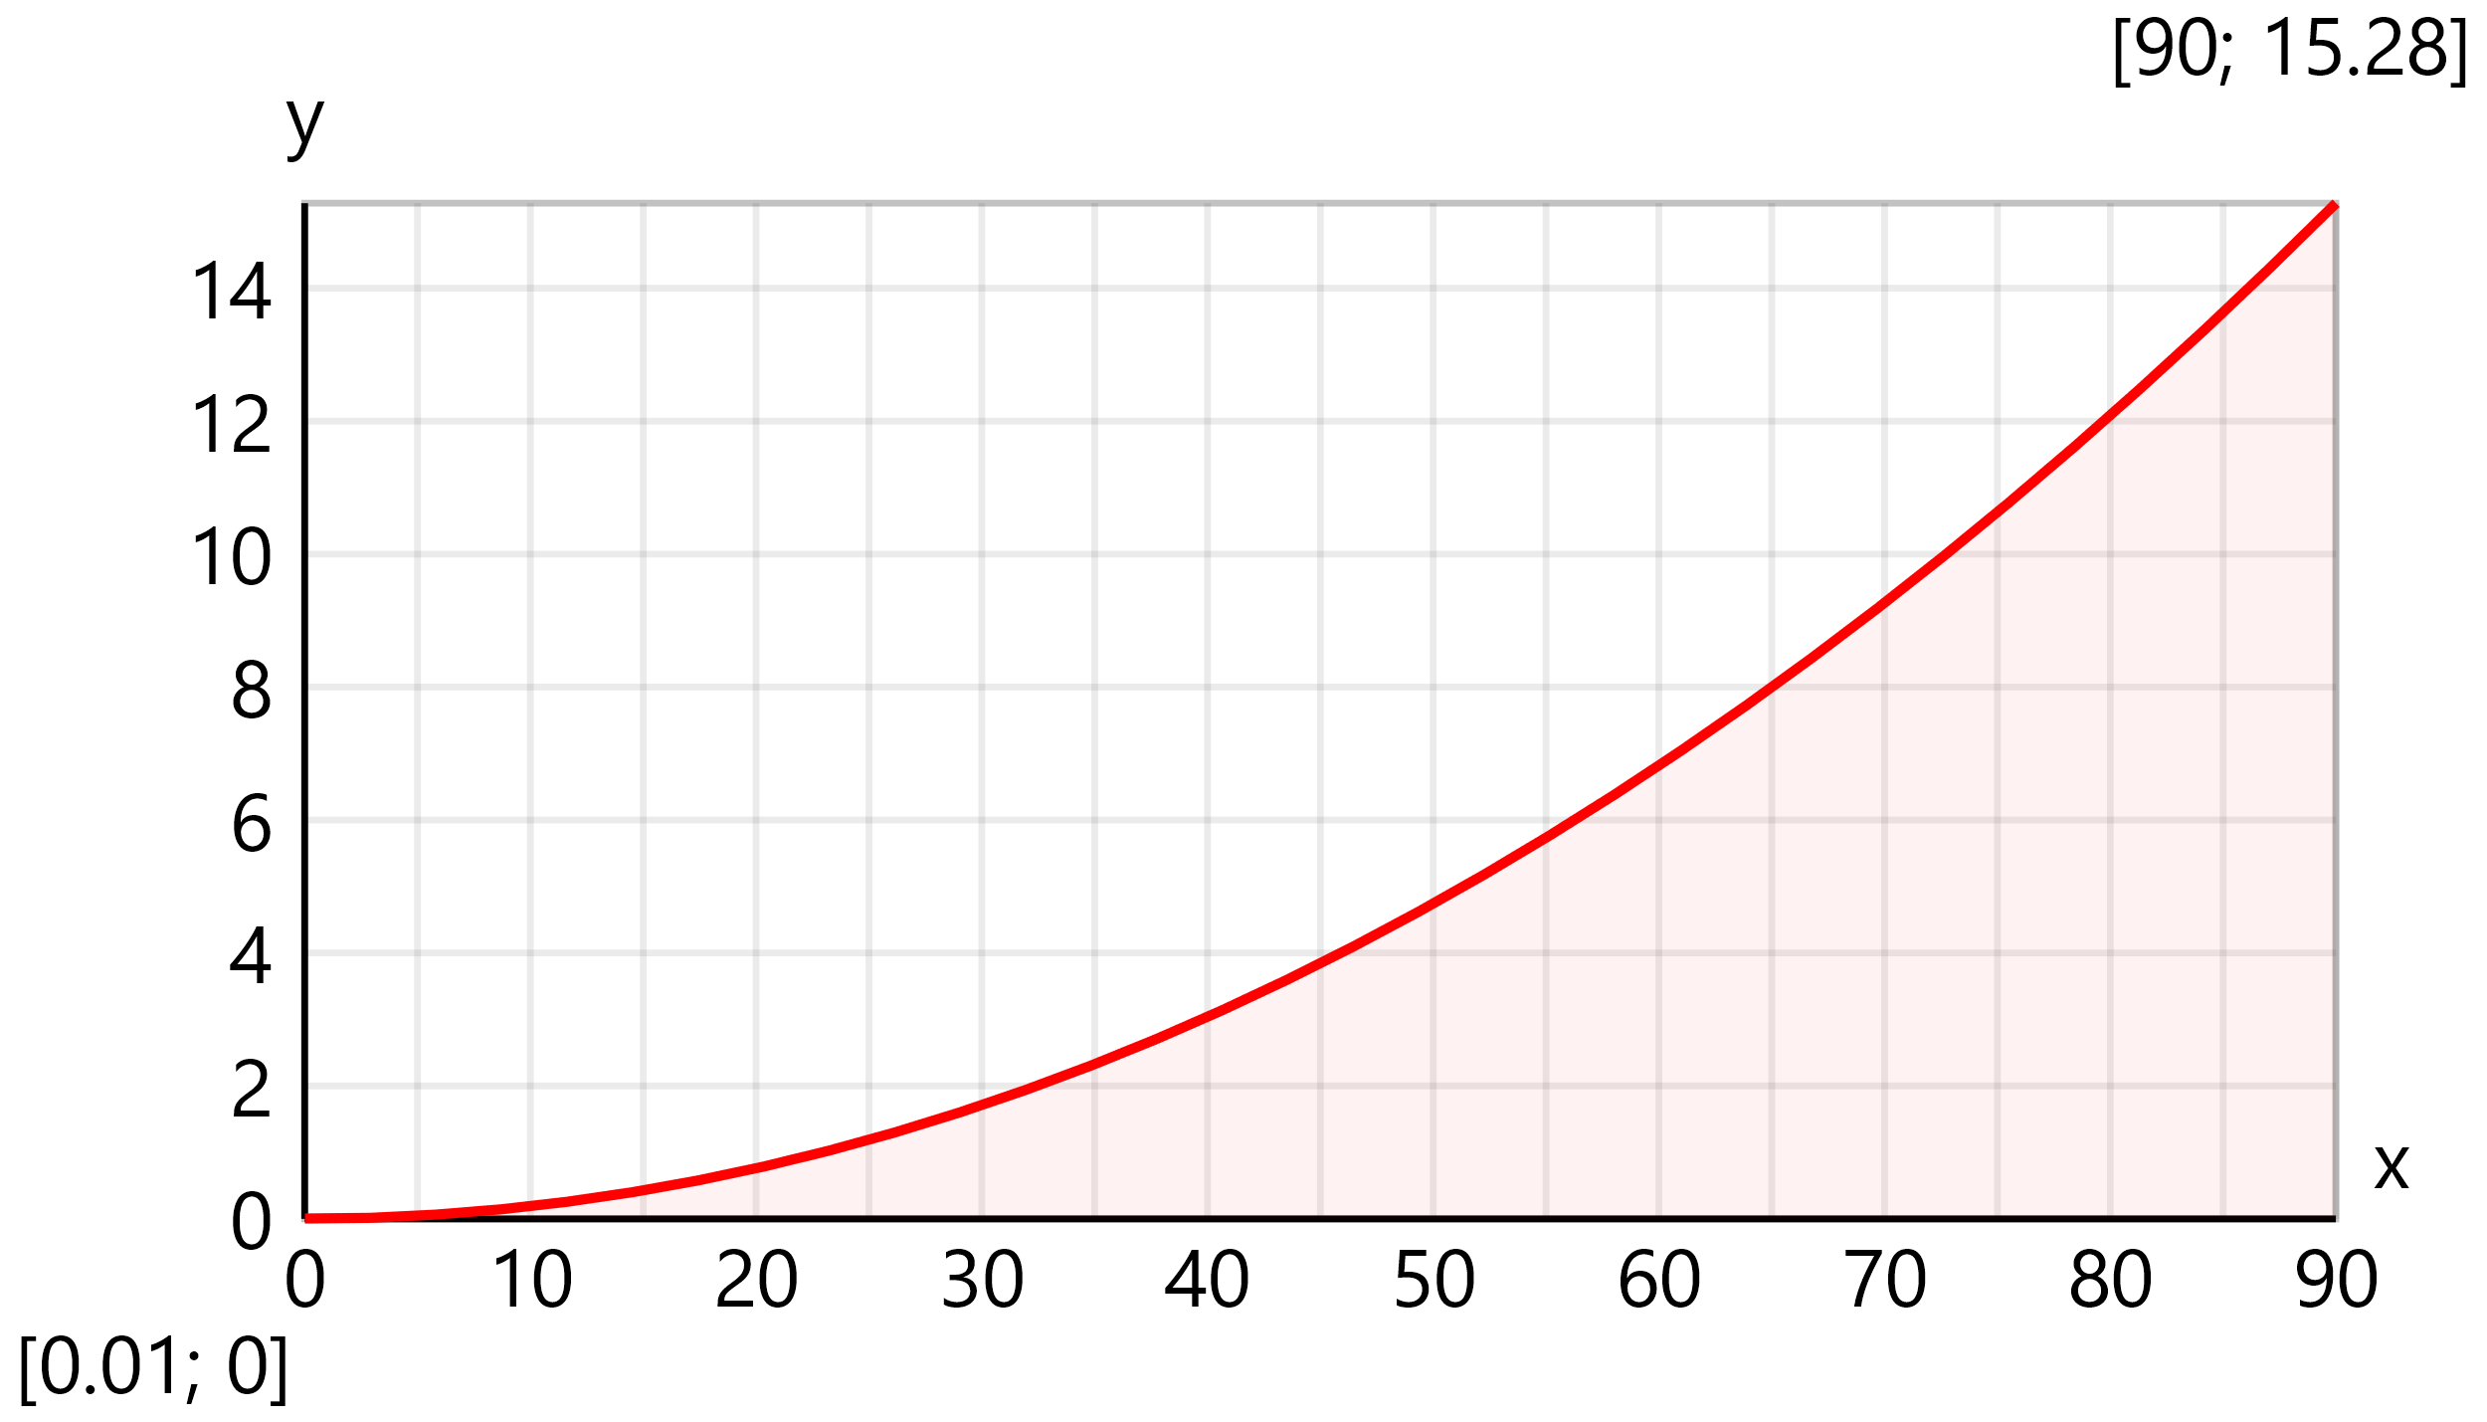
Solution by forward Euler method (explicit)
For that purpose, the II order equation is reduced to the following system of I order equations
$θ'=ω$ and $ω'=\frac{g}{l}·\left(\text{sin}\left(\text{-}θ\right)\right)$
The solution is performed iteratively
Step size - $h=0.05\text{ s}$ Number of steps - $n=\frac{t_{max}}{h}=200$
For each time step $n=200$ the values for the next step will be obtained by using the following equstions
$θ$ _{n+1} = $θ$ _{n} + $h$ · $ω$ _{n}
$ω$ _{n+1} = $ω$ _{n} + $h·\frac{g}{l}$ · sin $θ$ _{n}
Allocate vectors
${\vec{θ}}_{fwE}=\text{vector}\left(n\right)=\left[0 0 0 0 0 0 0 0 0 0 0 0 0 0 0 0 0 0 0 0 ... 0\right]$
${\vec{ω}}_{fwE}=\text{vector}\left(n\right)=\left[0 0 0 0 0 0 0 0 0 0 0 0 0 0 0 0 0 0 0 0 ... 0\right]$
$${\vec{E}}_{fwE}=\text{vector}\left(n\right)=\left[0 0 0 0 0 0 0 0 0 0 0 0 0 0 0 0 0 0 0 0 ... 0\right]$$
Set initial conditions
${{\vec{θ}}_{fwE}}_{.}=\frac{θ_{0}}{1\text{ rad}}=\text{-}1.05$ , ${{\vec{ω}}_{fwE}}_{.}=\frac{0}{\text{ s}}$
Perform Euler steps
Rotation - ${{\vec{θ}}_{fwE}}_{.}={{\vec{θ}}_{fwE}}_{.}+h·{{\vec{ω}}_{fwE}}_{.}=\text{-}1.05$
Angular velocity - ${{\vec{ω}}_{fwE}}_{.}={{\vec{ω}}_{fwE}}_{.}+h·\frac{g}{l}·\left(\text{sin}\left(\text{-}{{\vec{θ}}_{fwE}}_{.}\right)\right)=0.425{\text{ s}}^{-1}$
Energy - ${{\vec{E}}_{fwE}}_{.}=m·l^{2}·\left(\frac{1}{2}·{{{\vec{ω}}_{fwE}}_{.}}^{2}+\frac{g}{l}·\left(1-\text{cos}\left({{\vec{θ}}_{fwE}}_{.}\right)\right)\right)=4.9\text{ J}$
Solution by backward Euler method (implicit)
The following iterative procedure is applied:
$θ$ _{n+1} = $θ$ _{n} + $h$ · $ω$ _{n+1}
$ω$ _{n+1} = $ω$ _{n} + $h·\frac{g}{l}$ · sin $θ$ _{n+1}
Allocate vectors
${\vec{θ}}_{bwE}=\text{vector}\left(n\right)=\left[0 0 0 0 0 0 0 0 0 0 0 0 0 0 0 0 0 0 0 0 ... 0\right]$
${\vec{ω}}_{bwE}=\text{vector}\left(n\right)=\left[0 0 0 0 0 0 0 0 0 0 0 0 0 0 0 0 0 0 0 0 ... 0\right]$
$${\vec{E}}_{bwE}=\text{vector}\left(n\right)=\left[0 0 0 0 0 0 0 0 0 0 0 0 0 0 0 0 0 0 0 0 ... 0\right]$$
Set initial conditions
${{\vec{θ}}_{bwE}}_{.}=\frac{θ_{0}}{1\text{ rad}}=\text{-}1.05$ , ${{\vec{ω}}_{bwE}}_{.}=\frac{0}{\text{ s}}$
Perform Euler steps
$$f\left(θ\right)={{\vec{θ}}_{bwE}}_{.i}+h·\left({{\vec{ω}}_{bwE}}_{.i}+h·\frac{g}{l}·\left(\text{sin}\left(\text{-}θ\right)\right)\right)-θ$$
Rotation - ${{\vec{θ}}_{bwE}}_{.}=\$Root\left\{f\left(θ\right)=0;θ∈\left[\text{-}2·π;2·π\right]\right\}=\text{-}1.03$
Angular velocity - ${{\vec{ω}}_{bwE}}_{.}={{\vec{ω}}_{bwE}}_{.}+h·\frac{g}{l}·\left(\text{sin}\left(\text{-}{{\vec{θ}}_{bwE}}_{.}\right)\right)=0.419{\text{ s}}^{-1}$
Energy - ${{\vec{E}}_{bwE}}_{.}=m·l^{2}·\left(\frac{1}{2}·{{{\vec{ω}}_{bwE}}_{.}}^{2}+\frac{g}{l}·\left(1-\text{cos}\left({{\vec{θ}}_{bwE}}_{.}\right)\right)\right)=4.9\text{ J}$

Solution by Crank–Nicolson method (IMEX)
The following iterative procedure is applied:
$θ$ _{n+1} = $θ$ _{n} + $\frac{h}{2}$ ( $ω$ _{n} + $ω$ _{n+1} )
$ω$ _{n+1} = $ω$ _{n} + $\frac{h·g}{2·l}$ ( sin $θ$ _{n} + sin $θ$ _{n+1} )
Allocate vectors
${\vec{θ}}_{CN}=\text{vector}\left(n\right)=\left[0 0 0 0 0 0 0 0 0 0 0 0 0 0 0 0 0 0 0 0 ... 0\right]$
${\vec{ω}}_{CN}=\text{vector}\left(n\right)=\left[0 0 0 0 0 0 0 0 0 0 0 0 0 0 0 0 0 0 0 0 ... 0\right]$
${\vec{E}}_{CN}=\text{vector}\left(n\right)=\left[0 0 0 0 0 0 0 0 0 0 0 0 0 0 0 0 0 0 0 0 ... 0\right]$
Set initial conditions
${{\vec{θ}}_{CN}}_{.}=\frac{θ_{0}}{1\text{ rad}}=\text{-}1.05$ , ${{\vec{ω}}_{CN}}_{.}=\frac{0}{\text{ s}}$
Perform Euler steps
$$f\left(θ\right)={{\vec{θ}}_{CN}}_{.i}+\frac{h}{2}·\left(2·{{\vec{ω}}_{CN}}_{.i}+\frac{h·g}{2·l}·\left(\text{sin}\left(\text{-}{{\vec{θ}}_{CN}}_{.i}\right)+\left(\text{sin}\left(\text{-}θ\right)\right)\right)\right)-θ$$
Rotation - ${{\vec{θ}}_{CN}}_{.}=\$Root\left\{f\left(θ\right)=0;θ∈\left[\text{-}2·π;2·π\right]\right\}=\text{-}1.04$
Angular velocity - ${{\vec{ω}}_{CN}}_{.}={{\vec{ω}}_{CN}}_{.}+\frac{h·g}{2·l}·\left(\text{sin}\left(\text{-}{{\vec{θ}}_{CN}}_{.}\right)+\left(\text{sin}\left(\text{-}{{\vec{θ}}_{CN}}_{.}\right)\right)\right)=0.423{\text{ s}}^{-1}$
Energy - ${{\vec{E}}_{CN}}_{.}=m·l^{2}·\left(\frac{1}{2}·{{{\vec{ω}}_{CN}}_{.}}^{2}+\frac{g}{l}·\left(1-\text{cos}\left({{\vec{θ}}_{CN}}_{.}\right)\right)\right)=4.9\text{ J}$
Solution by Runge-Kutta RK4 method (explicit)
The following iterative procedure is applied:
First step (k₁) - | $k_{1,θ}=ω_{i}$ , | $k_{1,ω}=\frac{g}{l}·\left(\text{sin}\left(\text{-}θ_{i}\right)\right)$
Second step (k₂) - | $k_{2,θ}=ω_{i}+0.5·h·k_{1,ω}$ , | $k_{2,ω}=\frac{g}{l}·\left(\text{sin}\left(\text{-}\left(θ_{i}+0.5·h·k_{1,θ}\right)\right)\right)$
Third step (k₃) - | $k_{3,θ}=ω_{i}+0.5·h·k_{2,ω}$ , | $k_{3,ω}=\frac{g}{l}·\left(\text{sin}\left(\text{-}\left(θ_{i}+0.5·h·k_{2,θ}\right)\right)\right)$
Fourth step (k₄) - | $k_{4,θ}=ω_{i}+h·k_{3,ω}$ , | $k_{4,ω}=\frac{g}{l}·\left(\text{sin}\left(\text{-}\left(θ_{i}+h·k_{3,θ}\right)\right)\right)$
Update values using weighted averages
$θ$ _{n+1} = $θ_{i}+\frac{h}{6}·\left(k_{1,θ}+2·k_{2,θ}+2·k_{3,θ}+k_{4,θ}\right)$
$ω$ _{n+1} = $ω_{i}+\frac{h}{6}·\left(k_{1,ω}+2·k_{2,ω}+2·k_{3,ω}+k_{4,ω}\right)$
Allocate vectors
${\vec{θ}}_{RK4}=\text{vector}\left(n\right)=\left[0 0 0 0 0 0 0 0 0 0 0 0 0 0 0 0 0 0 0 0 ... 0\right]$
${\vec{ω}}_{RK4}=\text{vector}\left(n\right)=\left[0 0 0 0 0 0 0 0 0 0 0 0 0 0 0 0 0 0 0 0 ... 0\right]$
$${\vec{E}}_{RK4}=\text{vector}\left(n\right)=\left[0 0 0 0 0 0 0 0 0 0 0 0 0 0 0 0 0 0 0 0 ... 0\right]$$
Set initial conditions
${{\vec{θ}}_{RK4}}_{.}=\frac{θ_{0}}{1\text{ rad}}=\text{-}1.05$ , ${{\vec{ω}}_{RK4}}_{.}=\frac{0}{\text{ s}}$
Perform Runge-Kutta 4 steps
RK4 factors
$k_{1,θ}={{\vec{ω}}_{RK4}}_{.}=0{\text{ s}}^{-1}$ , $k_{1,ω}=\frac{g}{l}·\left(\text{sin}\left(\text{-}{{\vec{θ}}_{RK4}}_{.}\right)\right)=8.49{\text{ s}}^{-2}$
$$k_{2,θ}={{\vec{ω}}_{RK4}}_{.}+0.5·h·k_{1,ω}=0.212{\text{ s}}^{-1}$$
$$k_{2,ω}=\frac{g}{l}·\left(\text{sin}\left(\text{-}\left({{\vec{θ}}_{RK4}}_{.}+0.5·h·k_{1,θ}\right)\right)\right)=8.49{\text{ s}}^{-2}$$
$$k_{3,θ}={{\vec{ω}}_{RK4}}_{.}+0.5·h·k_{2,ω}=0.212{\text{ s}}^{-1}$$
$$k_{3,ω}=\frac{g}{l}·\left(\text{sin}\left(\text{-}\left({{\vec{θ}}_{RK4}}_{.}+0.5·h·k_{2,θ}\right)\right)\right)=8.47{\text{ s}}^{-2}$$
$$k_{4,θ}={{\vec{ω}}_{RK4}}_{.}+h·k_{3,ω}=0.423{\text{ s}}^{-1}$$
$$k_{4,ω}=\frac{g}{l}·\left(\text{sin}\left(\text{-}\left({{\vec{θ}}_{RK4}}_{.}+h·k_{3,θ}\right)\right)\right)=8.44{\text{ s}}^{-2}$$
Update values using weighted averages
Rotation - ${{\vec{θ}}_{RK4}}_{.}={{\vec{θ}}_{RK4}}_{.}+\frac{h}{6}·\left(k_{1,θ}+2·k_{2,θ}+2·k_{3,θ}+k_{4,θ}\right)=\text{-}1.04$
Angular velocity - ${{\vec{ω}}_{RK4}}_{.}={{\vec{ω}}_{RK4}}_{.}+\frac{h}{6}·\left(k_{1,ω}+2·k_{2,ω}+2·k_{3,ω}+k_{4,ω}\right)=0.424{\text{ s}}^{-1}$
Energy - ${{\vec{E}}_{RK4}}_{.}=m·l^{2}·\left(\frac{1}{2}·{{{\vec{ω}}_{RK4}}_{.}}^{2}+\frac{g}{l}·\left(1-\text{cos}\left({{\vec{θ}}_{RK4}}_{.}\right)\right)\right)=4.9\text{ J}$

Plot results
Rotation θ [deg] versus time t [s] plot  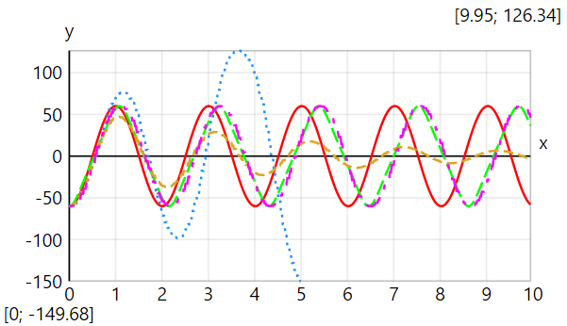 | ━━━━ Small rotations  ━━━━ Large rotations  · · · · · · Forward Euler  ━ ━ ━ Backward Euler  ━ · ━ · Crank–Nicolson
Energy E [J] versus time t [s] plot
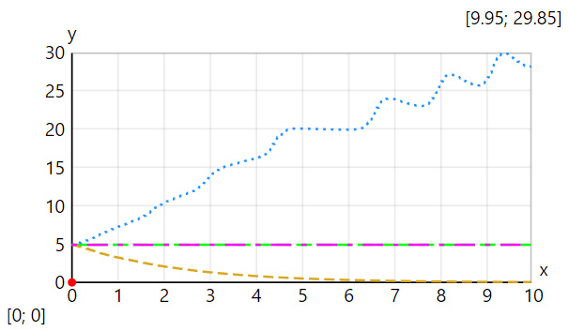
Comparision of Crank–Nicolson and Runge-Kutta 4 methods
Rotation θ [deg] versus time t [s] plot
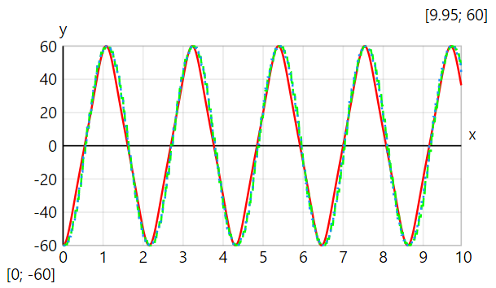 | ━━━━ Theoretical (large rot.)  ━ ━ ━ Crank–Nicolson (IMEX)  · · · · · · Runge-Kutta 4 (explicit)
Absolute error Δθ [°] versus time t [s] plot
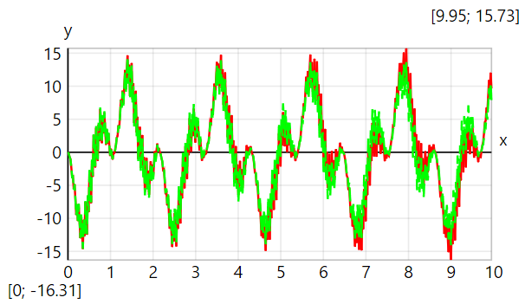 | ━━━━ Crank–Nicolson (IMEX)  ━ ━ ━ Runge-Kutta 4 (explicit)
Energy E [J] versus time t [s] plot
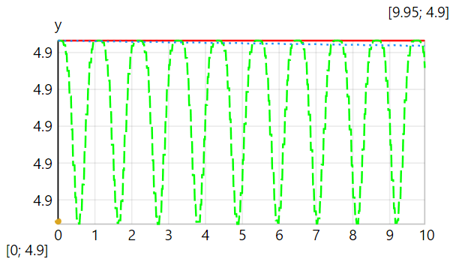 | ━━━━ Theoretical (large rot.)  ━ ━ ━ Crank–Nicolson (IMEX)  · · · · · · Runge-Kutta 4 (explicit)

